

NATIONAL UNIVERSITY OF SCINCE AND TECHNOLOGY

# FUNDAMENTALS OF PROGRAMMING

SUBMITTED TO:MUHAMMAD AFFAN

SUBMITTED BY:MUHAMMAD ABDULLAH

SECTION:ME-15(B)

REG # 461030

# TASK NO 1:

# 

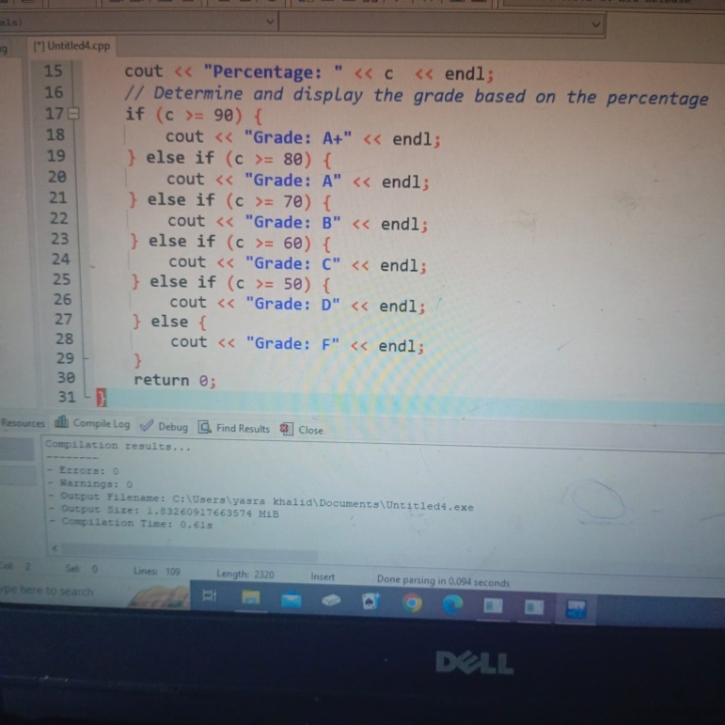

**RESULTS:**

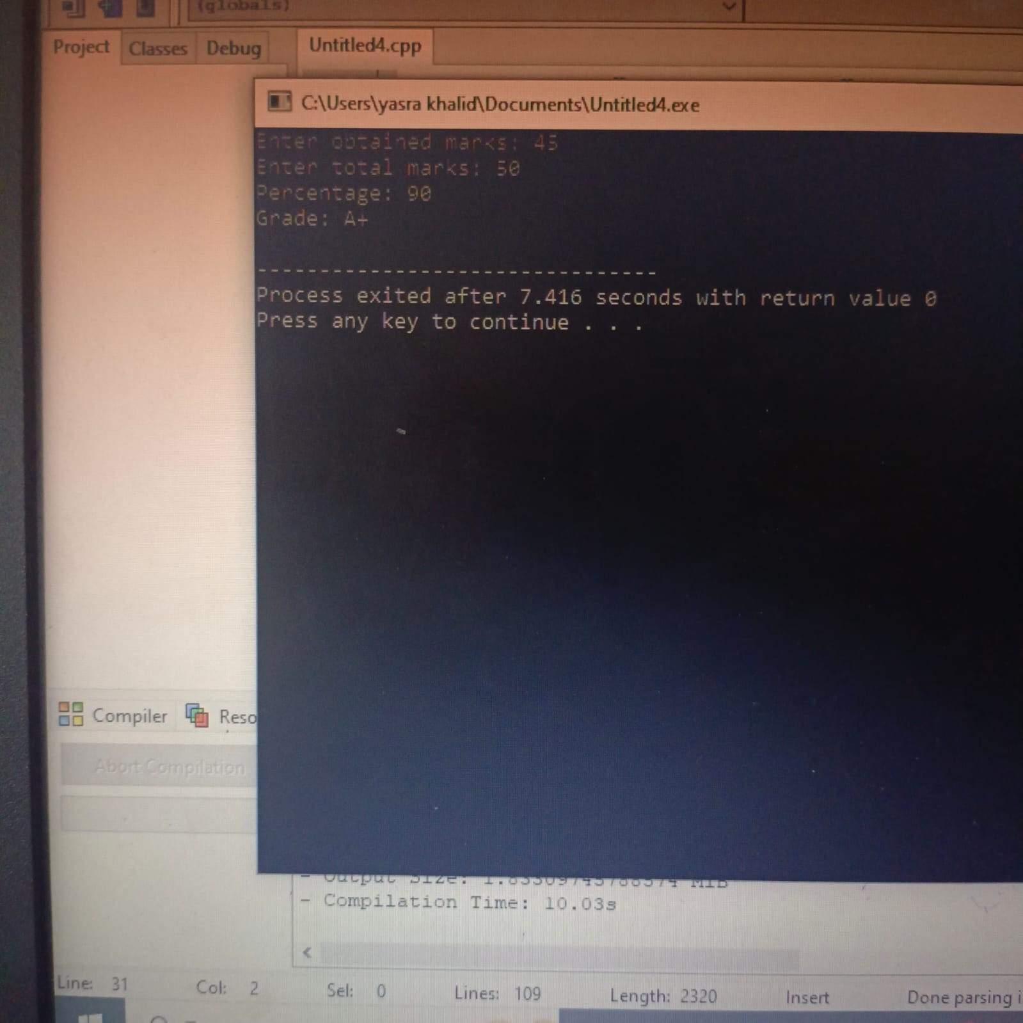

TASK NO 2:

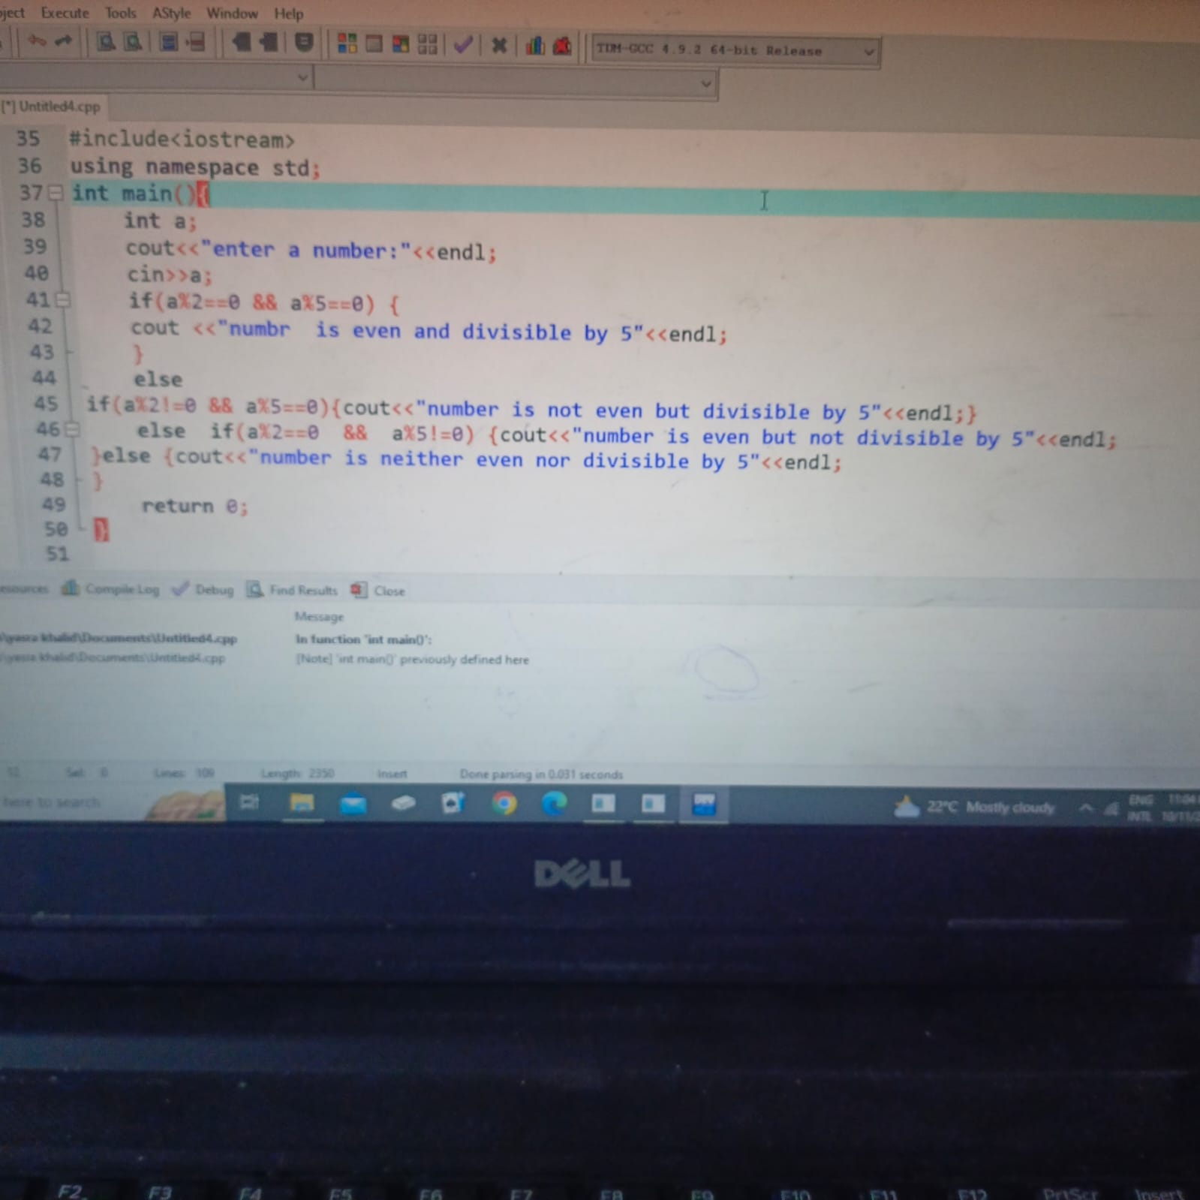

## 

## RESULTS:

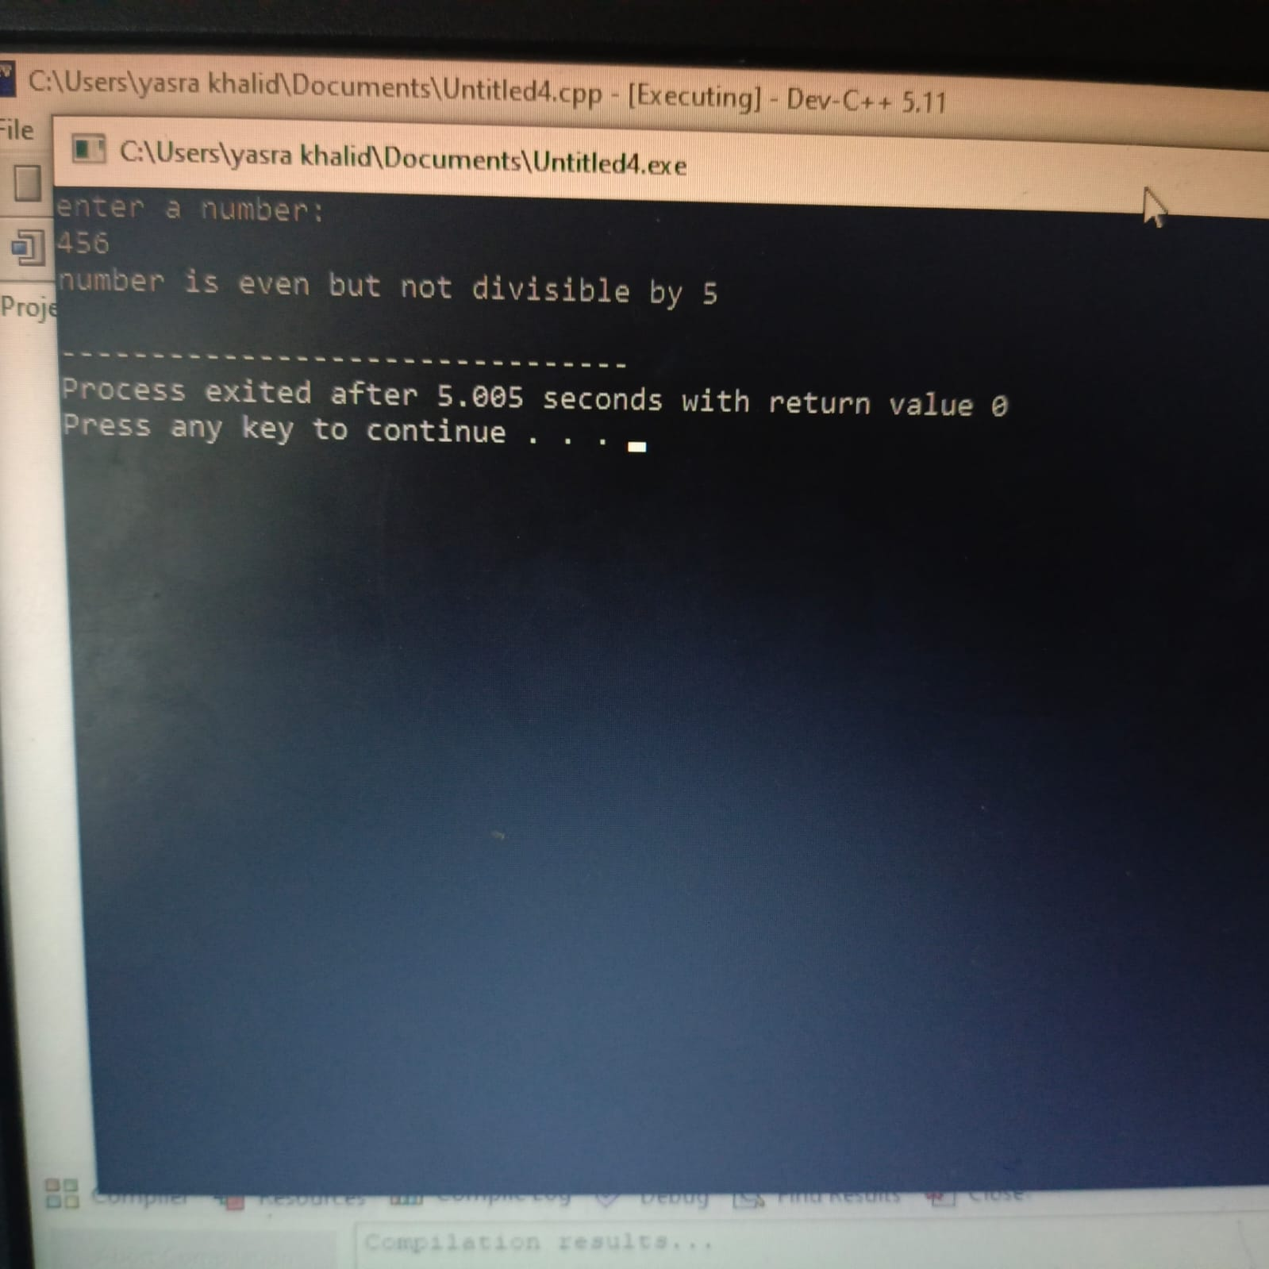

TASK NO 3:

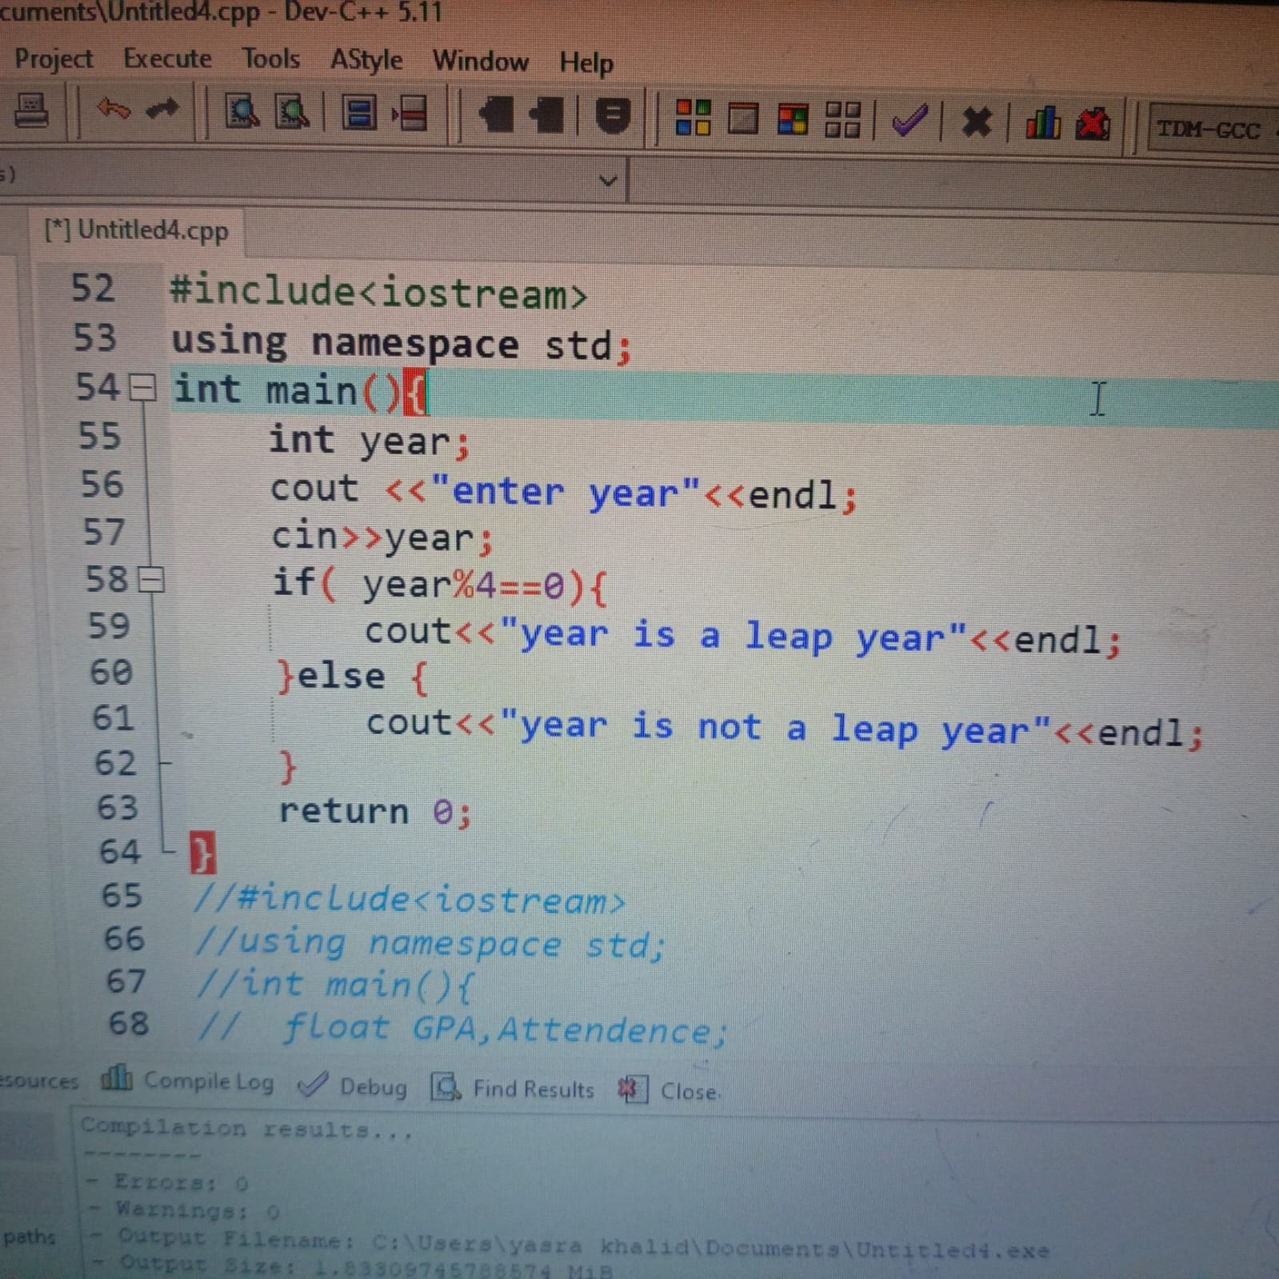

# RESULTS:

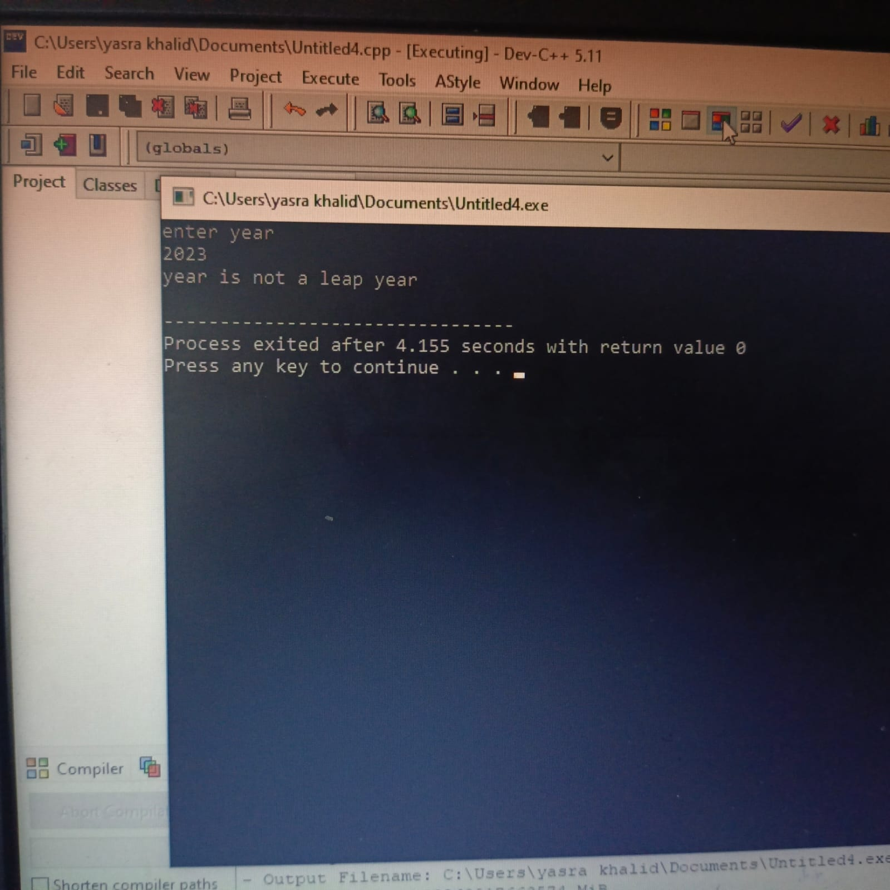

TASK NO 4:

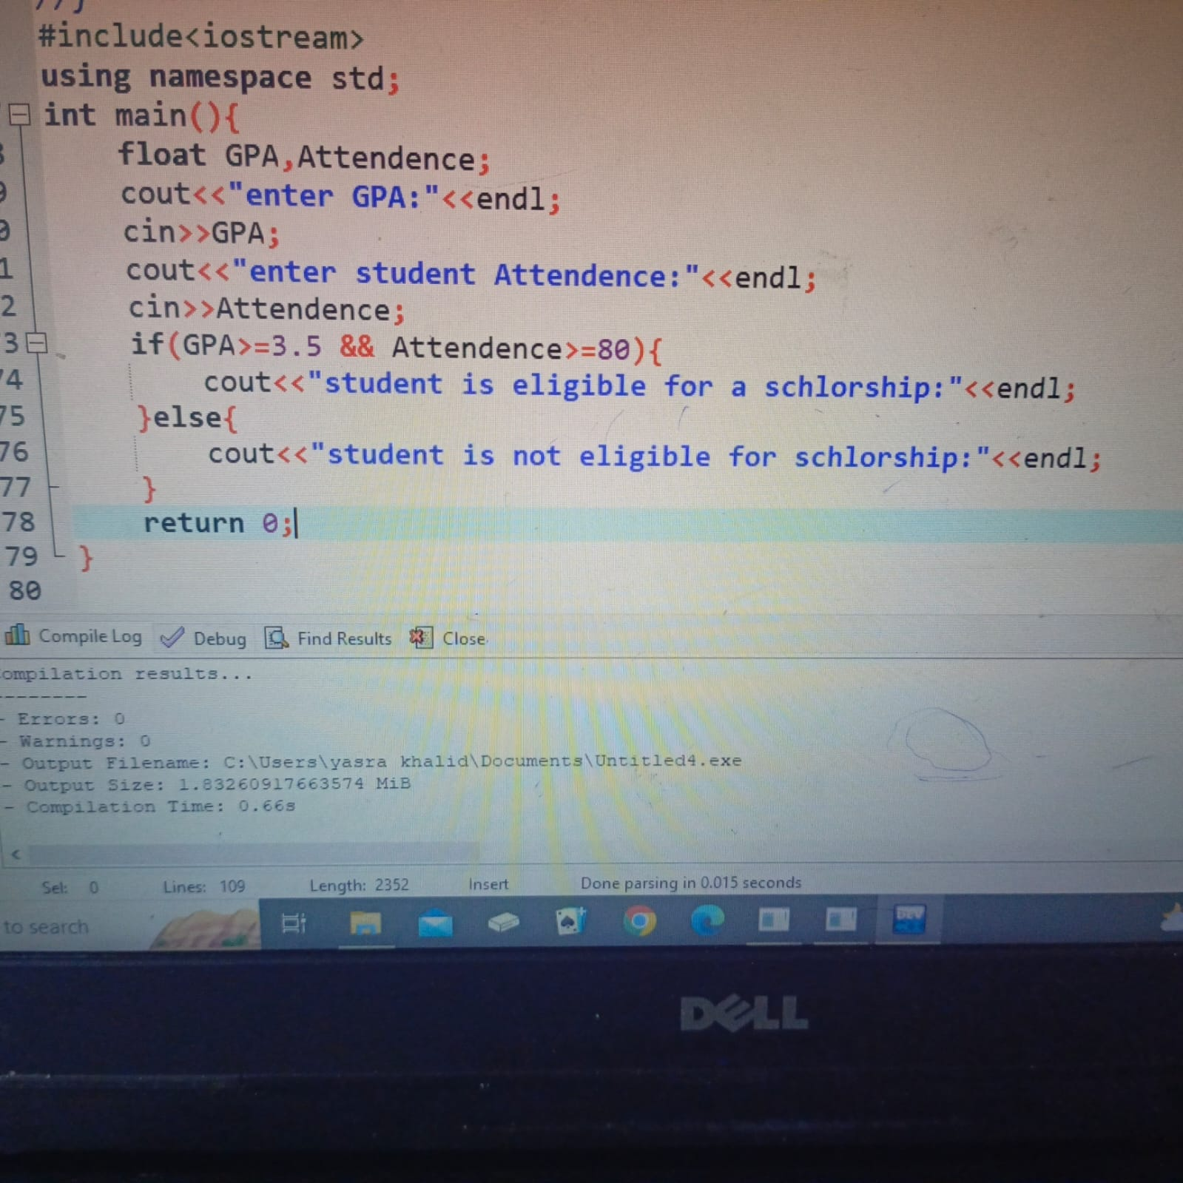

# RESULT:

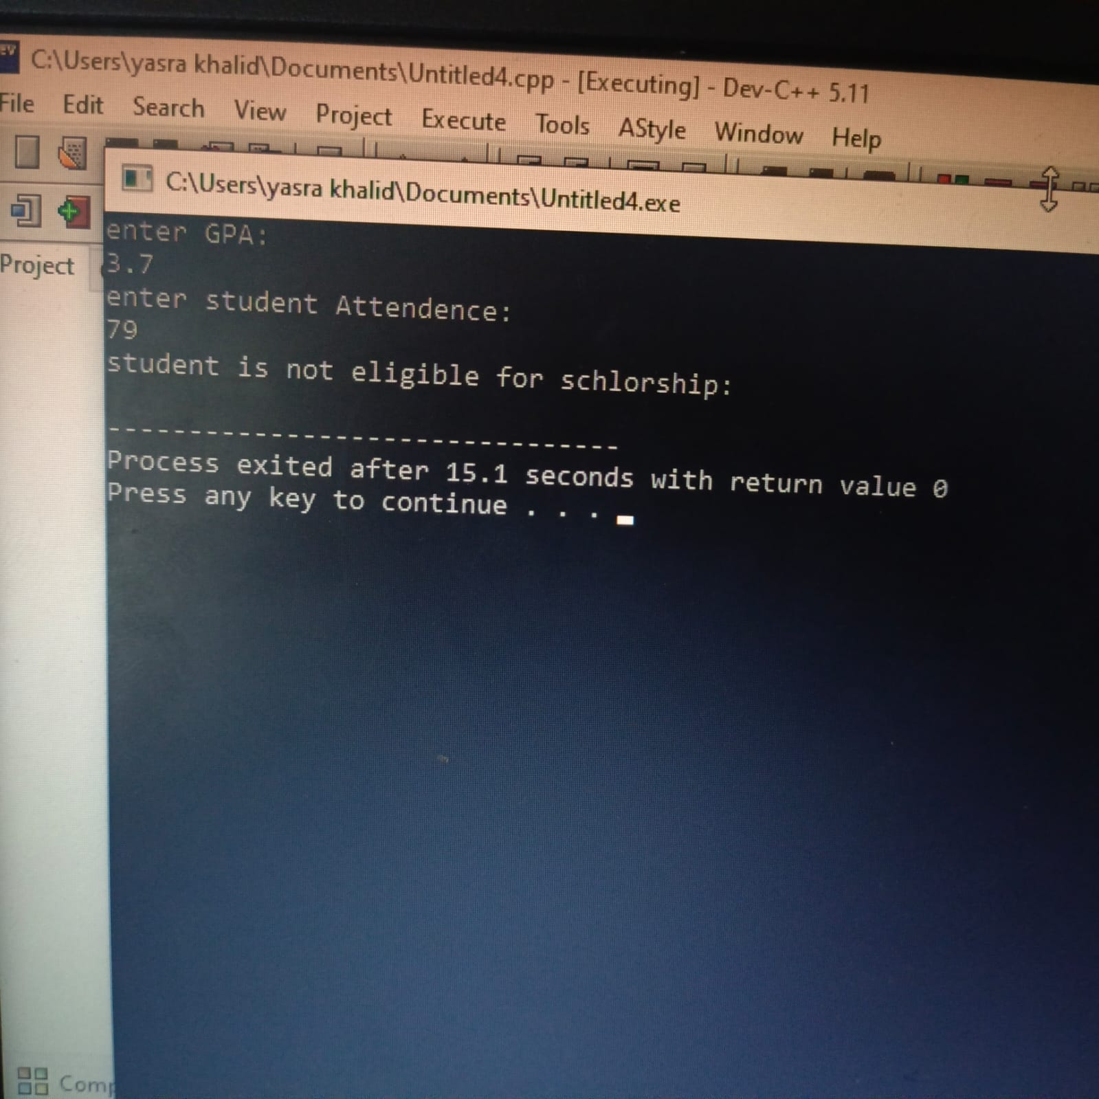

TASK NO 5:

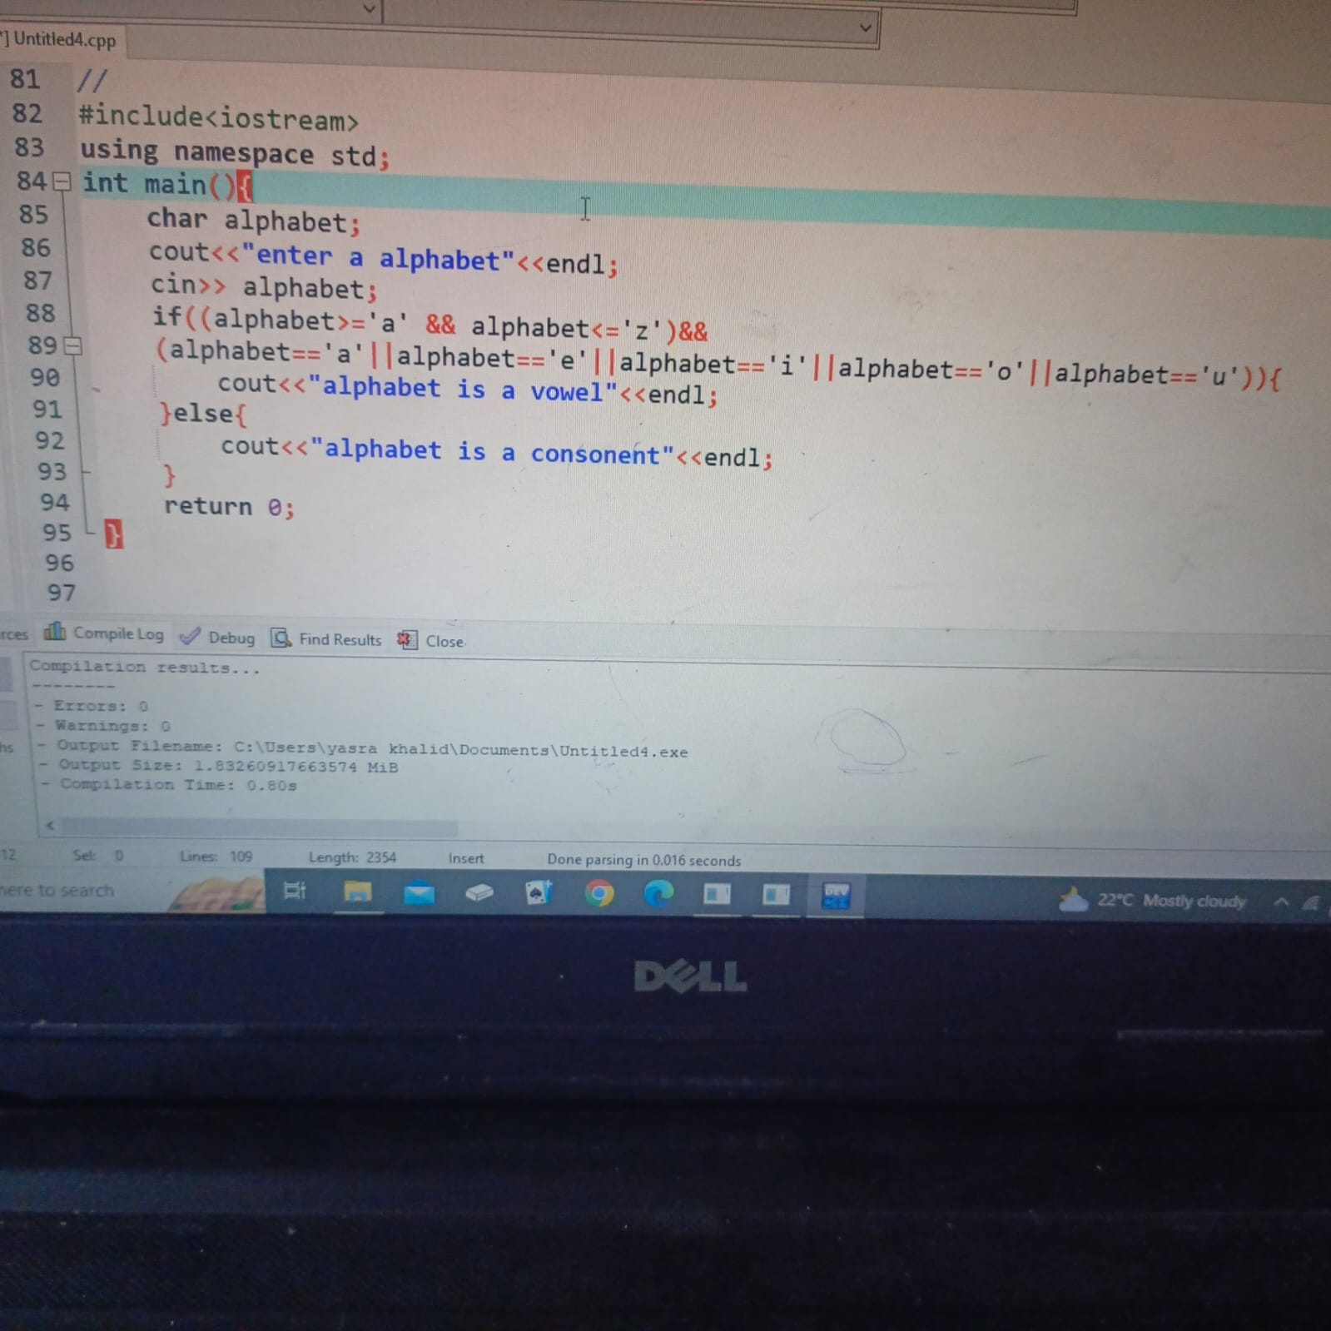

# RESULT:

